STUDENT PROFILE

<!DOCTYPE html>

<html>

<head>

</head>

<body>

<h1 align="center"> <b>STUDENT PROFILE </b></h1>

<fieldset>

<legend align="center"><b><h3> Student Profile Worksheet</h3></b> </legend>

<p>First Name: ____________________________________________</p>

<p>Surname: ________________________________________________</p>

<p>Address: ________________________________________________</p>

<p>Email Address: ___________________________________________</p>

<p>Date of Birth: ___________________________________________</p>

<p>Nationality: _____________________________________________</p>

<p>Mother Tongue: ___________________________________________</p>

<p>Other Languages: _________________________________________</p>

<p>School: _________________________________________________</p>

<p>Form: ___________________________________________________</p>

<p>These are some of my favourite things:</p>

<p>Sport: _________________________________________________</p>

<p>Book: _________________________________________________</p>

<p>School Subject: _________________________________________</p>

<p>TV Show: _______________________________________________</p>

<p>After school I like to ____________________________________</p>

<p>I want to be a ___________________________________________</p>

</body>

</fieldset>

</html>

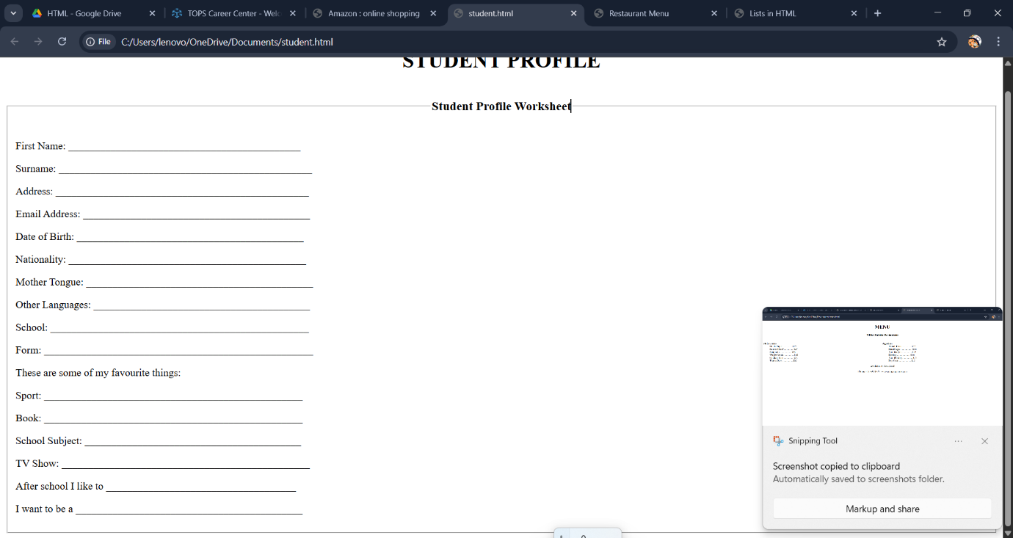

RESTAURNT MENU

<!DOCTYPE html>

<html>

<head>

<title>Restaurant Menu</title>

</head>

<body>

<h1 align="center"> <b> MENU </b></h1>

<h3 align="center">Nölke Zahida Restaurant</h3>

<div style="width:50%;float: left">

<dl>

<dt>Main Course</dt>

<dd>Black Paper ............... $27</dd>

<dd>Roasted Beef ............... $27</dd>

<dd>Spaghetti .................. $28</dd>

<dd>Wagyu Steak ................ $28</dd>

<dd>Chicken Rise ............... $22</dd>

<dd>Tender Rice ................ $22</dd>

</dl>

</div>

<div style="width:50%;float:left">

<dl>

<dt>Appetizer</dt>

<dd>French Fries ............... $12</dd>

<dd>Humburger .................. $14</dd>

<dd>Mini Burger ................ $12</dd>

<dd>Hotdog ..................... $14</dd>

<dd>Mini Hotdog ................ $12</dd>

<dd>Pop Corn ................... $12</dd>

</dl>

</div>

<br><br><br>

<br>

<p align="center">Available at: Your Food</p>

<p align="center">Phone: 312-692-0079 | www.companyname.com</p>

</body>

</html>

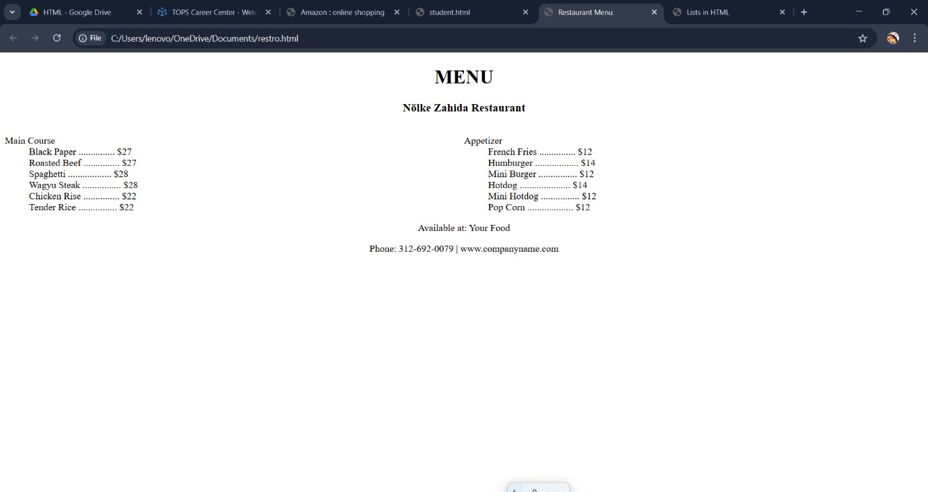

HTML LISTS

<!DOCTYPE html>

<html>

<head>

<title>Lists in HTML</title>

</head>

<body>

<h1 align="center"><b>Lists in HTML</b></h1>

<fieldset>

<div style ="width:33%;float: left";>

<h1 align="center">orderd list</h1>

<ol type="1">

<li>Information Gathering</li>

<li>Planning</li>

<li>Design</li>

<li>Development</li>

<li>Testing & Deployment</li>

<li>Maintenance</li>

</ol>

</div>

<fieldset>

<div style="width: 50%;float:left";>

<h1 align="center">unordered list</h1>

<ul type="disc">

<li>HTML</li>

<li>CSS</li>

</ul>

<ul type="circle">

<li>SQL</li>

<li>PHP</li>

</ul>

<ul type="disc">

<li>JavaScript</li>

<li>Python</li>

</ul>

</div>

<fieldset>

<div style="width:50%;float:left">

<h2 align="center">Description List</h2>

<dl>

<dt><b>HTML</b></dt>

<dd>HTML stands for Hyper Text Markup Language.<br> HTML is the standard markup language for creating Web pages HTML describes the structure of a Web page.</dd>

<dt><b>CSS</b></dt>

<dd>CSS is the acronym of "Cascading Style Sheets".<br> CSS is the language used to style an HTML document. CSS describes how HTML elements should be displayed.</dd>

<dt><b>PHP</b></dt>

<p>PHP is an acronym for "PHP: Hypertext Preprocessor". PHP is a server scripting language, and,a powerful tool for making dynamic and interactive Web pages.</p>

</dl>

</div>

</fieldset>

</body>

</html>

